PFsense setup and remote acces/port forwading

By: Jordan Abu-Zahra

**Purpose:**

the purpose of this lab was to get familiar with PfSense and learn how to set it up from scratch with just a laptop and USB then learn how to remote access into a neighboring computer on the same network.

**Background:**

PfSense is a software used as a router and in our case a firewall software and is setup as a DHCP server, DNS server, Wi-Fi access point, and VPN server all on one physical device like we did it on a old laptop with a fresh computer and a USB that we imaged with a software call Rufus and imaged it will PfSense. Then after we got it set up with a WAN (Wide area network) and a LAN (Local area network) and we got to set up remote access on one computer to take control over the neighboring computer.

PfSense is a stateful firewall meaning that it remembers information about connections flowing through the firewall so that it can automatically allow reply traffic, and this benefits the users of PfSense since they can get real time feedback on their filtering and their updates and monitor all the traffic that is sent out and into the firewall. Compared on how to set up PfSense vs Palo Alto, PfSense is way simpler for people to set up and navigate through the GUI and will be more user friendly to people new to cyber security and will get a base knowledge on how firewalls work.

Remote access was the second part of our lab and people use remote access to access a computer or network from a geographical distance through a network connection and we used it to hack into our neighboring computer. And the purpose of a PFsense fire wall is to detect hackers that want to gain access to your network, so we could get a good amount of security since most things in this world are moving into the technological side and most things are online and you need to protect your data.

**Steps**

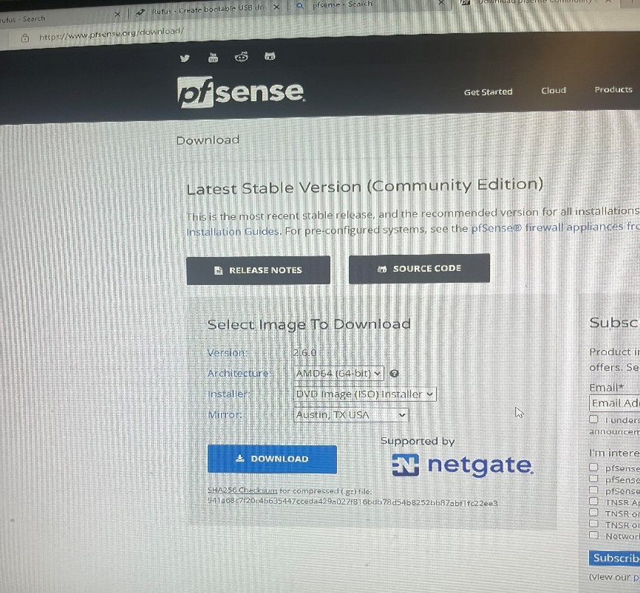

**#1 download PfSense and Rufus onto your computer with these settings**

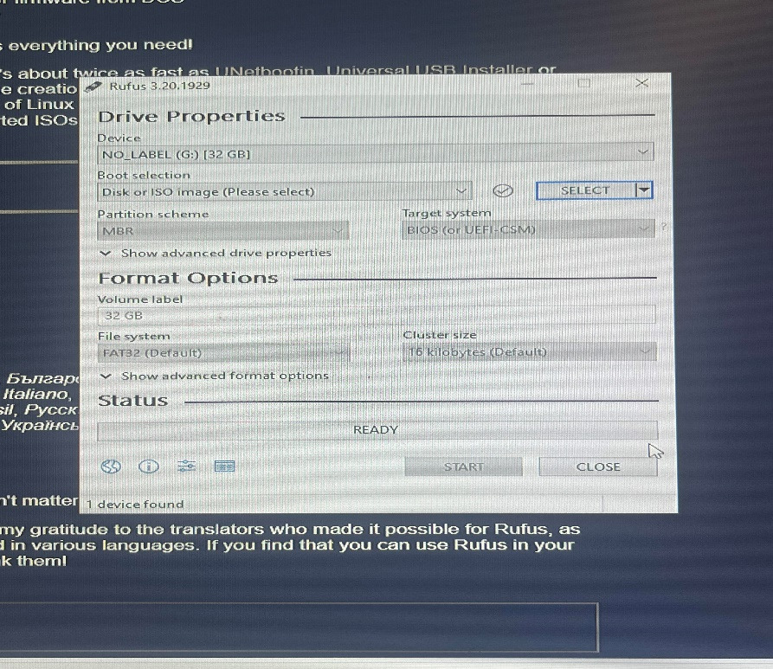

**#2 download Rufus and when you get to this screen elect tab pick your PfSense folder and then click select to image your drive with PfSense**

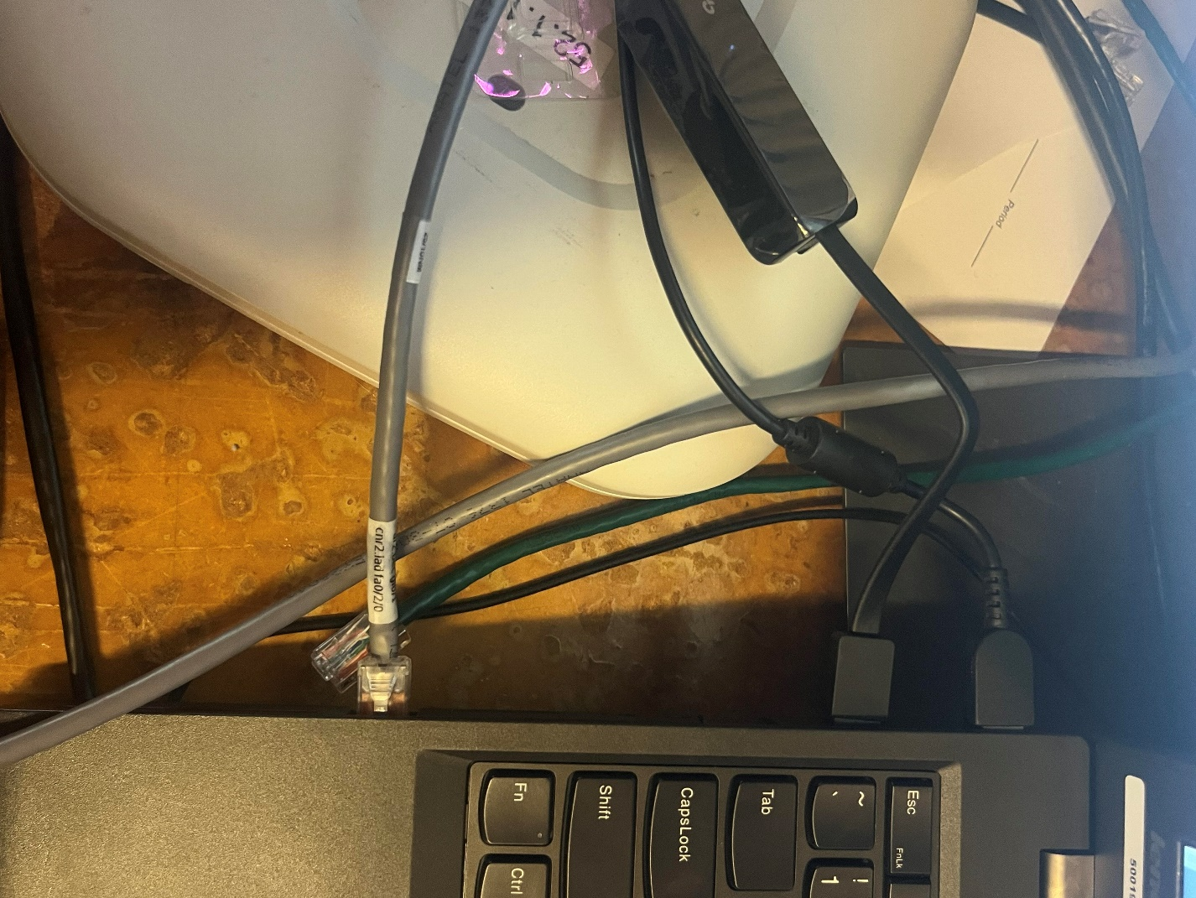

**#3 get a ethernet adapter and plug that into your LAN and plug the other ethernet cable into your WAN and then plug your USB into the other side and then boot up your computer**

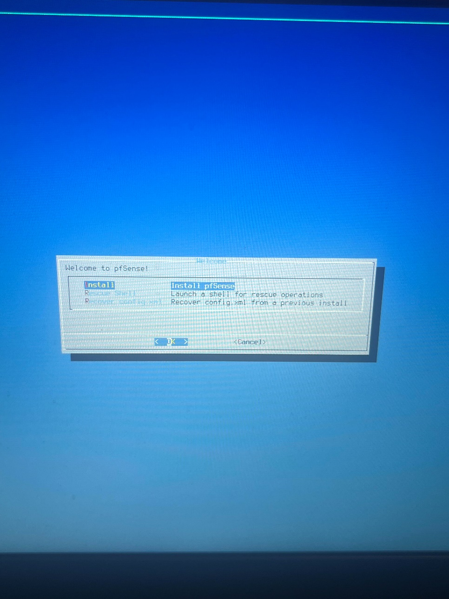

**#4 when you boot up your computer you will see this screen and choose the highlight option**

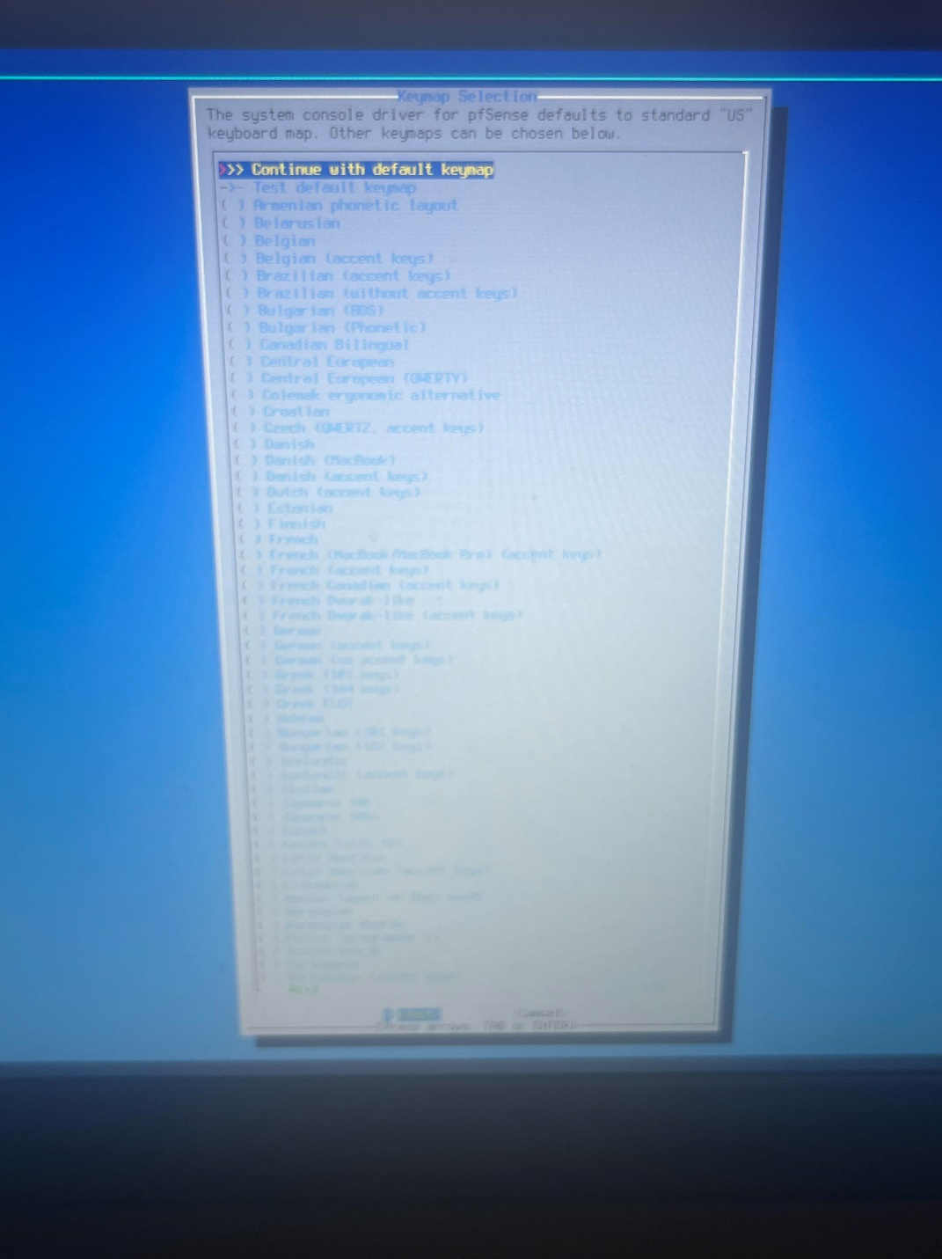

**#5 select the highlighted option then go forward**

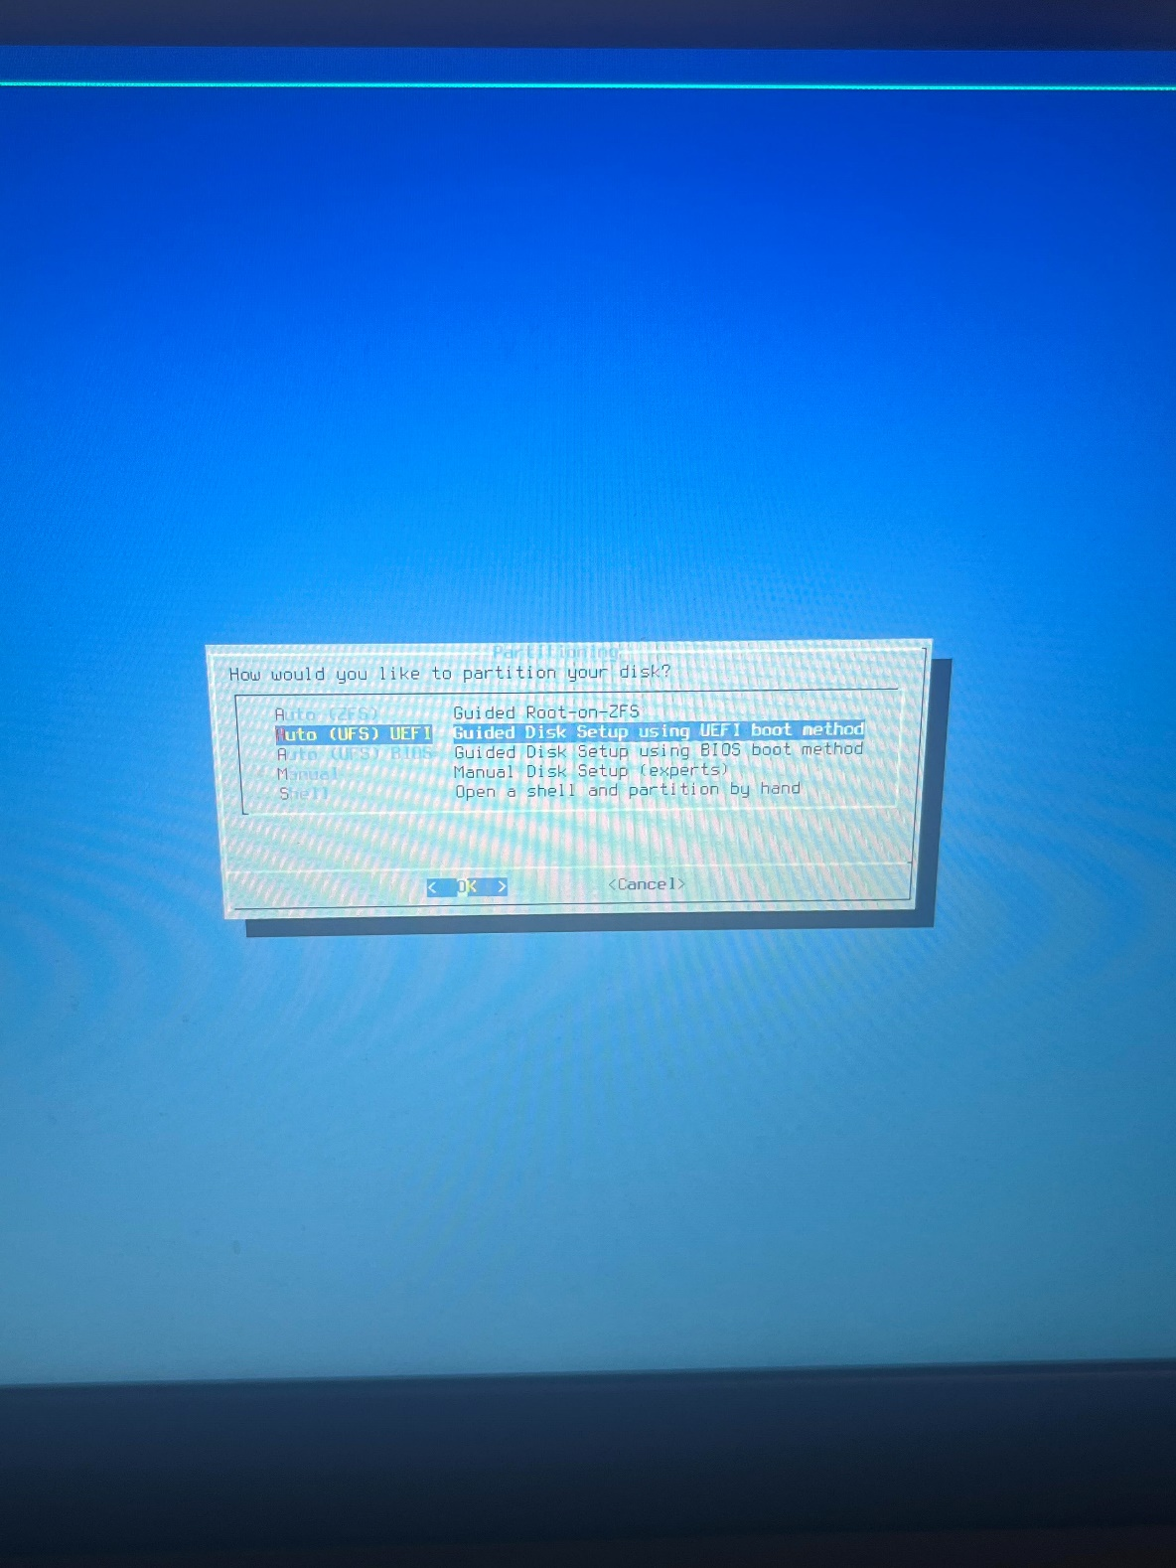

**#6 pick the highlighted option and click ok**

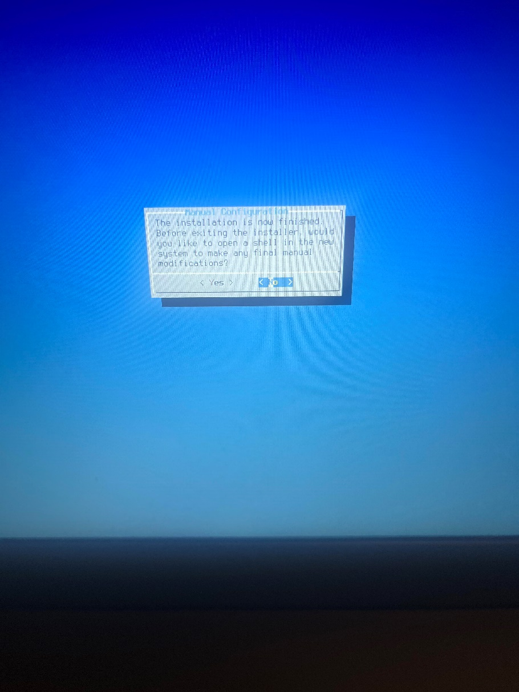

**#7 say no to powershell**

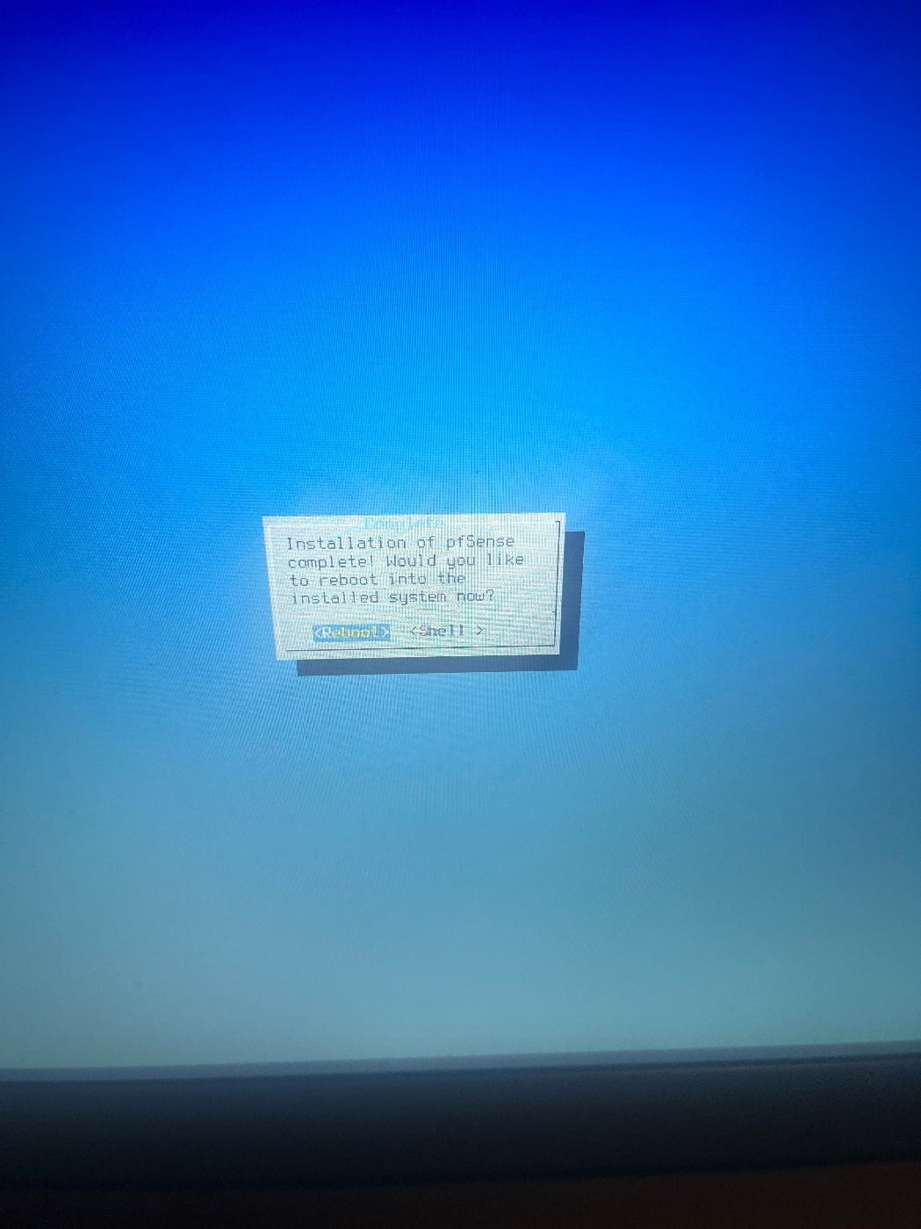

**#8 then reboot into PfSense**

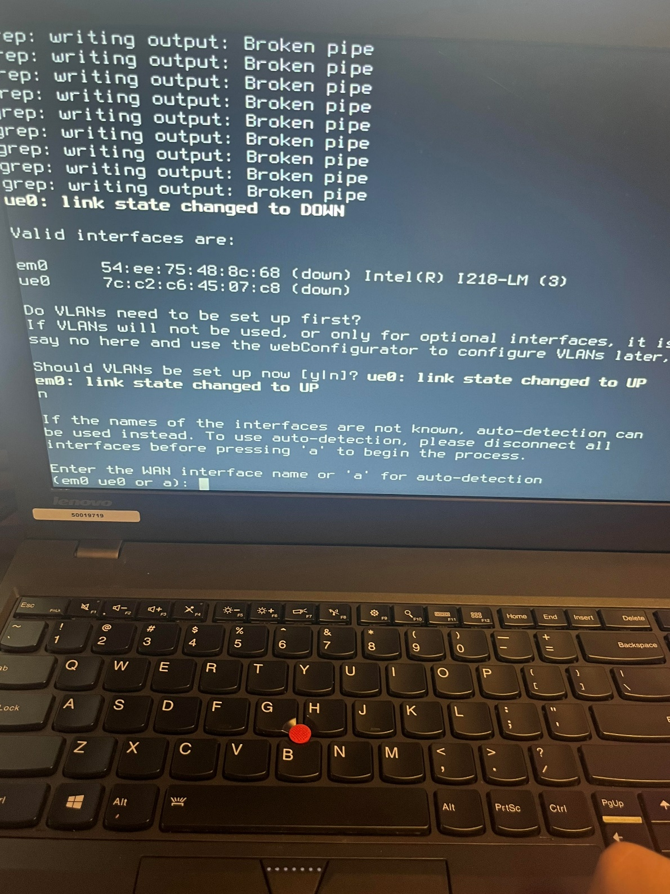

**#9 enter WAN interface name em0, enter LAN interface name, ue0 assign interfaces, WAN as DHCP client, WAN as DHCP server**

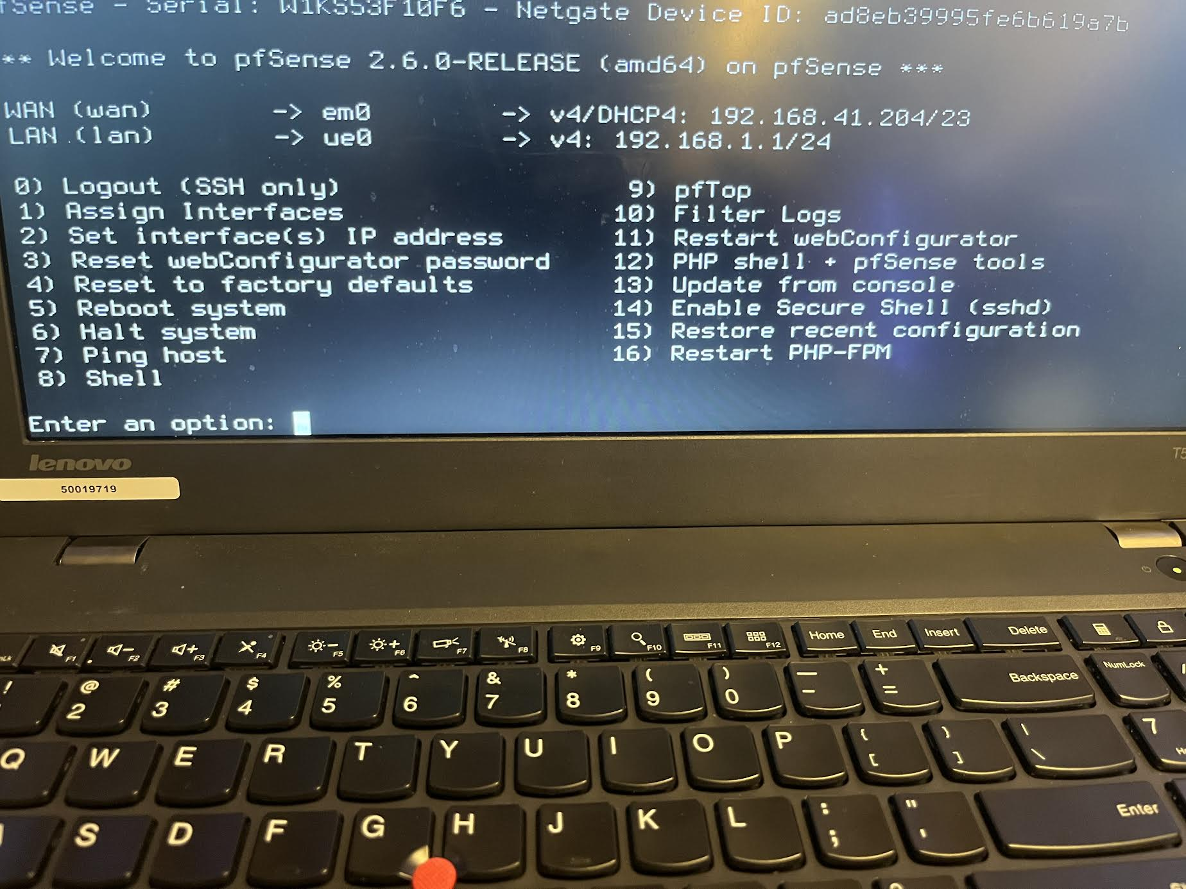

**#10 one you have completed step #9 you should see this screen if you don’t factory reset and try again**

**#11 set your PC to DHCP**

**#12 Log into the UI version of PFsense**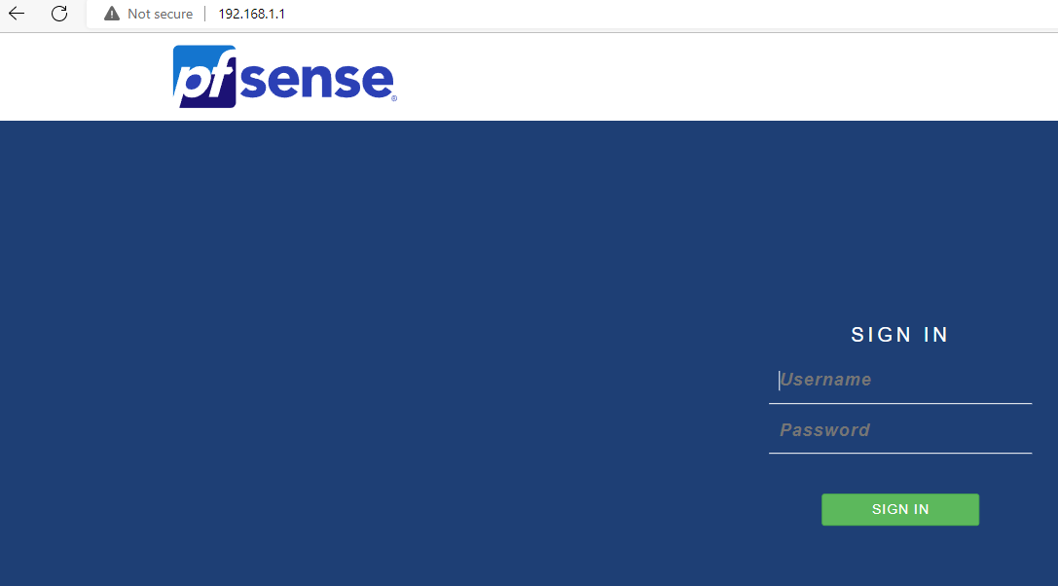

**#13 go to the firewall tab and on the drop down menu go to NAT**

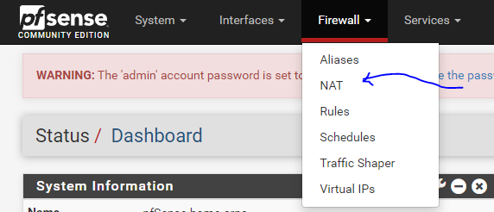

**#14 fill out this page**

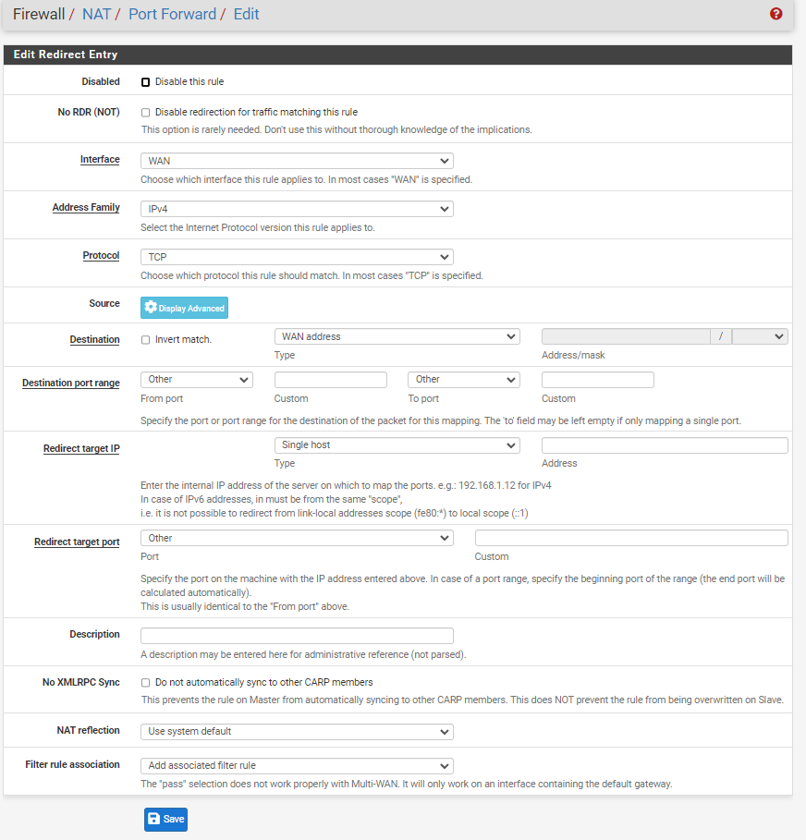

**#15 put in the IP address of the computer you want to remote access** 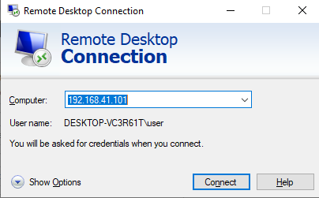

**Problems:**

A problem we had was that we could not get an address for our WAN/DHCP server so we had to factory reset until we could get one and we ended up getting one from resetting our PfSense and were able to go into the online GUI configuration. While configuring it online it will ask you to complete the 9 steps and we did so, but we set it up wrong and that caused us to get a 502 bad gateway error making us have to factory reset again this time skipping the steps. One last issue we had was a cable issue, our ethernet cable was a nonfunctioning wire that we had one of our classmates’ tests for us and then once we swapped the ethernet cable was swapped out everything worked, and we were able to continue with the lab with no further problems.

**Conclusion:**

We learned how to sup up PFsense from a hardrive that we imaged and made it into a SOHO configuration with remote access